**Young African ConneXions Annual Summit 2015**

**Speaker Biographies**

**CONGRESSWOMAN ELEANOR HOLMES NORTON**

**Congresswoman for the District of Columbia**

**Special Address**

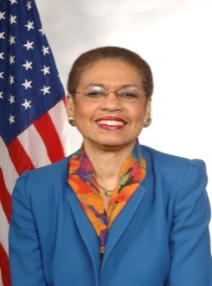Congresswoman Eleanor Holmes Norton, now in her thirteenth term as the Congresswoman for the District of Columbia, is the Ranking Member of the House Subcommittee on Highways and Transit. She serves on two committees: the Committee on Oversight and Government Reform and the Committee on Transportation and Infrastructure. Before her congressional service, President Jimmy Carter appointed her to serve as the first woman to chair the U.S. Equal Employment Opportunity Commission. She came to Congress as a national figure who had been a civil rights and feminist leader, tenured professor of law, and board member at three Fortune 500 companies. Congresswoman Norton has been named one of the 100 most important American women in one survey and one of the most powerful women in Washington in another. The Congresswoman's work for full congressional voting representation and for full democracy for the people of the District of Columbia continues her lifelong struggle for universal

human and civil rights.

**Anthony K. Wutoh**

**Ph.D., Provost and Chief Academic Officer, Howard University**

**Special Address**

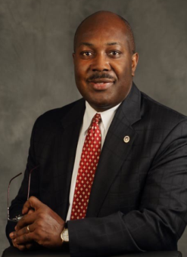Anthony K. Wutoh, Provost and Chief Academic Officer, at Howard University, was appointed as a new Commissioner of the Accreditation Council for Pharmacy Education (ACPE) International Services Program’s (ISP) International Commissionin 2014. A renowned researcher and clinician, Dr. Wutoh’s extensive work and study of HIV/AIDS in at-risk populations and combating stigma has contributed significantly to the reduction of transmission rates in Washington, DC and increased awareness both nationally and internationally. His research has resulted in more than 20 manuscript publications, international abstracts, posters and grants. Dr. Wutoh has served Howard University as Director of the College of Pharmacy’s Center of Excellence, Director and Senior Fellow for the Center for Minority Health Services Research and Chairman of the Institutional Review Board. Dr. Wutoh received a Bachelor of Arts degree in Biochemistry from the University of Maryland, Baltimore Countyand a Bachelor of Science in Pharmacy. He then completed a Ph.D. in Pharmacy Administration at the University of Maryland School of Pharmacy.

**H. E. MNINWA MAHLANGU**

**Ambassador, Republic of South Africa**

**Delivered by NOWETU LUTI**

**Deputy Chief of Mission**

**Keynote Address**

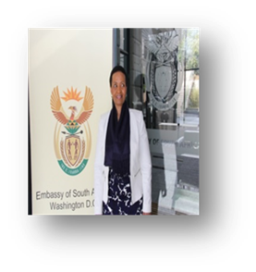Before assuming her current position as the Minister Plenipotentiary (Deputy Chief of Mission) in 2015, Nowetu Luti served as a diplomat in the Republic of Turkey and Canada. Ms. Luti played a major role in politics during the United Democratic Front period in the late 1980s in East London, Eastern Cape. When liberation movements were unbanned in 1990, she participated in the ANC Diplomatic Training in Malaysia and Norway. She received further training in India for the 12th Senior Diplomats and a Professional Course in International Economic Relations, Commercial Diplomacy and Management Techniques. She worked as the Director for Eastern Europe countries handling bilateral relations between South Africa and Azerbaijan, Belarus, Russian Federation, Serbia and the Republic of Turkey. She was one of the last groups of Heads of Mission/Ambassador’s Course that received training in diplomacy and international relations in the Netherlands in 2013. Ms. Luti is a teacher by profession and hails from the Eastern Cape Province in South Africa. Ms. Luti holds a Postgraduate Degree in Public Management.

**Naomi Ferguson**

**Mandela Washington Fellow, Howard University**

**Special Address**

Naomi Ferguson has been a doctor for the Seychelles Ministry of Health since April 2012. At home she is better known as Dr. Naomi Adeline and is currently working in community health centers, including the Youth Health Centre, where she provides primary health services. Outside work hours, she is involved in activities relating to increasing the health literacy of the Seychelles community. Her hobbies include snorkeling and scuba diving. Upon completion of the Mandela Washington Fellowship, Naomi plans to continue her work in public health education, and also to start projects to improve efficiency of health services in the Seychelles..

**Pape Samb**

**Chairman and CEO, Global Youth Innovation Network**

**Guest Speaker**

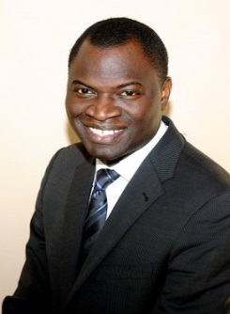Pape Samb is a social entrepreneur with 20 years of experience in youth entrepreneurship, women leadership, and partnership building. A driving force and empowering ‘agent of change’ for youth globally, Mr. Samb co-founded and serves as Chairman and CEO of the Global Youth Innovative Network (GYIN), a knowledge and business incubator for over 6,000 young leaders entrepreneurs, innovators and farmers in almost 100 countries. At GYIN, he develops programs and policies that address the root causes of youth unemployment, while increasing the opportunities young people have to obtain a decent job or start a successful business. He is an active public speaker on the national and international forefront and has spoken at Qatar Foundation, Gandhi Research Foundation, World Food Prize to name few. Mr. Samb has designed many projects including Global Shared Value Leadership (GSVL), Entrepreneurial, Innovation Based Experimental Learning (CEIBEL), Creating Opportunities for Rural Youth (CORY), Social Entrepreneurship Integration Program (SEIP), Children for Innovation, Entrepreneurship, and Leadership (CIEL). Mr. Samb holds a Bachelor of Science in Business Management and a Masters Degree in Executive Leadership from American University.

**Panel I:** ***Youth Leadership: Public Service, Community Advocacy, and entrepreneurship***

**Jeannine Scott**

**President, U.S. – Angola Chamber of Commerce**

**Panelist**

Jeannine B. Scott is the President of the U.S.–Angola Chamber of Commerce and Founder & Principal of America to Africa Consulting (A2A), LLC. A seasoned professional in the field of humanitarian and economic development work, Ms. Scott brings over 30 years of experience in the field of international development, spanning the private, non-profit, multi-lateral agency and US Government sectors, both domestically and globally. Notable among her earlier career has been: service as the Senior Vice President of Africare, one of the largest and oldest non-profits focusing on Africa; and an earlier appointment for the U.S. Department of Treasury, under the Clinton Administration, as Advisor and Alternate U.S. Executive Director to the African Development Bank Group (AfDB) – the largest financial institution on the African continent. Hailing from New Orleans, Ms. Scott graduated from Sacred Heart Academy. Ms. Scott graduated fromVassar College and holds an M.A. degree from Yale University.

**Greg Carr**

**Ph.D., JD, Chair of Afro-American Studies and Adjunct Faculty at School of Law, Howard University**

**Panelist**

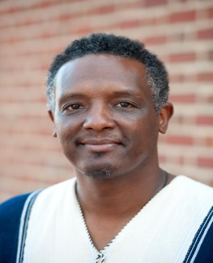Greg Carr is Chair of Afro-American Studies Department at Howard University and Adjunct Faculty at the Howard School of Law. The First Vice President of the Association for the Study of Classical African Civilizations and a former board member of the National Council for Black Studies, Dr. Carr has been named Professor of the Year several times by Howard students. He was also named 2013-14 “HBCU Male Faculty Member of the Year” at the 4th annual HBCU Media Week Awards. Dr. Carr designed the curriculum framework for Philadelphia’s mandatory high school African American History course and co-founded Philadelphia Freedom Schools, a community-based academic initiative that has involved over 13,000 K-12 students. Dr. Carr's publications have appeared in, among other places, The African American Studies Reader, Socialism and Democracy, Africana Studies, Publications of the Modern Language Association of America, The National Urban League’s 2012 State of Black America and Malcolm X: A Historical Reader. Dr. Carr has appeared as a commentator on contemporary and historical events and issues in a wide range of local, national and international media. He blogs at drgregcarr.com and on Twitter at @AfricanaCarr and can be reached at gcarr@howard.edu.

**Menna Demessie**

**Ph.D., Vice President of Policy and Research, Congressional Black Caucus Foundation, Inc.**

**Panelist**

Dr. Menna Demessie is vice president of policy and a senior research and policy analyst for the Congressional Black Caucus Foundation, Inc. (CBCF) where she works on public policy issues relevant to African Americans. She is also an adjunct professor at the University of California Washington Center.In her latest publication, *Toward A More Inclusive America: African Americans & Voting Rights*, she discusses the significance of restrictive voting law changes in the context of the Voting Rights Act and new age discrimination. She serves as the historian and is an executive board member for the National Conference of Black Political Scientists (NCOBPS) and has served as the National Youth Coordinator for the Society of Ethiopians Established in the Diaspora (SEED) since 2000.Dr. Demessie holds a joint doctorate in Public Policy and Political Science, a Master of Arts in Political Science and Certificate in African American, African and Black Transnational Studies from the University of Michigan and a Bachelor of Arts in Economics and Law and Society from Oberlin College.

**Nangamso Koza**

**Mandela Washingon Fellow, Howard University**

**Panelist**

Nangamso Koza has over six years’ experience in youth, educational, and community development. She was born in Hewu in the Eastern Cape and single-handedly established Inqubela Foundation, an education-focused charitable trust that develops schools in developing communities into leading centers of academic excellence and leadership development. Since its inception, the foundation has served over 2,000 learners and over 28 schools and offers one-of-a-kind leadership and literacy development programs. Their flagship program, Intsika YeSizwe Fellowship has turned ordinary citizens into thought-leaders passionate about Africa's development. Nangamso is a published author, an experienced researcher, and program designer. Through her research and publications company, Umthawelanga she plans on publishing more on African history and philosophy. Upon her return, Nangamso plans on expanding the Inqubela Foundation into a self-sustaining trust and to reach out to more schools in the Eastern Cape.

**Krista Johnson**

**Ph.D., Professor of African Studies, Howard University**

**Moderator**

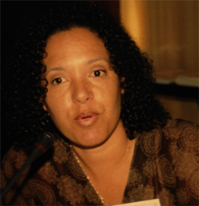 Krista Johnson is an Associate Professor in the Department of African Studies at Howard University. A political scientist by training, her current research focuses on AIDS governance and donor funding for HIV and AIDS in southern Africa. She has lived and traveled extensively throughout southern Africa. In 2012, she completed a Fulbright Fellowship based at the Centre for the Study of HIV and AIDS at the University of Botswana. She currently serves on a number of advisory and selection committees for international programs and fellowships, including Howard University’s Fulbright American Association of University Women International Fellowship Review Panel. She has also held consultancies with the United States Agency for International Development, and the U.S. State Department, and is regularly asked to lecture at the Foreign Service Institute.

**Panel II: *Strengthening Inter-African Linkages: Technology, Knowledge, and Information Exchange***

**Nina Oduro  
Founder and President, AfricanDevJobs.com**

**Panelist**

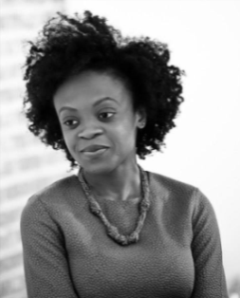Nina Oduro is the founder and President of AfricanDevJobs.com, a platform for Africa-based development job opportunities and career advice. The site offers insights into African development careers with a focus on highlighting the contributions of Africans and the African diaspora in the field. Nina has worked as an education advisor, trainer, and facilitator for programs and initiatives aimed at positive youth development in the US and Africa. She is currently a Catalyst for the International Labour Organization's Global Working Group on Decent Work for Youth and serves on the Learning Metrics Task Force Global Citizenship Education Working Group convened by UNESCO, the Brookings Institution, and the Global Education First Initiative's Youth Advocacy Group. She was honored as the 2013 DAWNer of the Year by the Diaspora African Women's Network (DAWN) and has been featured in The Guardian, Afro Elle Magazine, and on Impact Africa Radio Show.  Nina received a Master’s degree in African-American Studies from Columbia University and an undergraduate degree in Political and Social Thought from the University of Virginia.

**Semhar Araia**

**CEO, Semai Consulting, LLC.**

**Panelist**

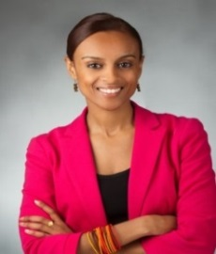Semhar Araia is CEO of Semai Consulting, a global leadership, diversity and diaspora engagement firm dedicated to providing training, coaching, and research for public and private clients. She is the founder and executive director of the Diaspora African Women’s Network (DAWN), an organization whose mission is to develop and support the next generation of African diaspora women focused on African affairs. Semhar is an adjunct professor at George Washington University's Elliott School of International Affairs and has previously served as an attorney for the implementation of the Eritrea-Ethiopia peace process. Semhar is a White House Champion of Change and African Union Diaspora Awardee of the Year, recognized for her contributions through DAWN and the African diaspora community. She was born in New York City to Eritrean immigrant parents and resides in DC.

**Tegene Baharu**

**Chief Technology Officer, DC Office of the Chief Technology Officer**

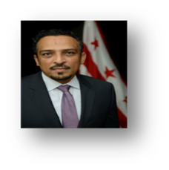 **Panelist**

An engineer by trade, Tegene’s journey as a thought-leader was paved with 10 years of fortune-500 private sector and an Information Communications and Technology (ICT) expert.   Tegene began working for the District in 2001, when he made a commitment to pubic safety through technology following 9/11, later becoming the lead for the original team of engineers who built DC-Net.  He has served in Deputy CTO capacities with oversight of Infrastructure Services, Citywide IT Security Operations, Telecom Governance, and DC-Net. Tegene’s operations serve 90+ District agencies and several Federal Entities. He was appointed Chief Technology Office of the District of Columbia by Mayor Muriel Bowser on March 11, 2015.

**Amadou Daffe**

**CEO and Co-founder of CODERS4AFRICA**

**Panelist**

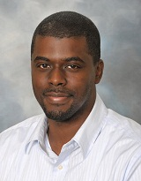By trade, Amadou Daffe is a software architect and engineer with a decade of experience in enterprise application development. With the intent of one day putting thousands of Africans to work developing software applications, Amadou co-founded Coders4Africa (C4A) in 2009 with the goal capitalize on his industry experience and deep understanding of the culture and needs of IT professionals to become Africa’s largest software outsourcing organization. C4A serves a global customer base while building Africa’s largest software developer network and creating essential applications for the continent’s agriculture, business, consumer, education, and health care markets.

**Emira Woods Co-Director**

**Director of Global Impact, ThoughtWorks**

**Moderator**

[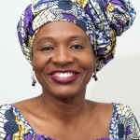](http://fpif.org/wp-content/uploads/2013/04/Emira-Woods.jpg)Emira Woods is the Director of Global Impact at ThoughtWorks. She has written on a range of issues from debt, trade, and development to U.S. military policy. Emira serves on the Board of Directors of Africa Action, Just Associates, Global Justice and the Financial Policy Forum. Prior to joining IPS, she was program manager for the Committee on Development Policy and Practice at InterAction, serving as a principal staff contact for advocacy at the UN, the international financial institutions, USAID and Treasury. Ms. Woods is a regular commentator on CNN*,* BBC, *Al Jazeera* and Voice of America. She is chair of the Board of Africa Action and serves on the advisory committee of the Zimbabwe Alliance as well as the Humanity United/Trustafrica Liberia program. She is a member of the Network Council of Jubilee USA. Emira completed her undergraduate studies at Columbia University and her graduate studies at Harvard.